1. **Implement Tic –Tac –Toe Game.**

**Code:**

**board={1:' ',2:' ',3:' ',**

**4:' ',5:' ',6:' ',**

**7:' ',8:' ',9:' '**

**}**

**print("Sonal , 1BM22CS286")**

**def printBoard(board):**

**print(board[1]+'|'+board[2]+'|'+board[3])**

**print('-+-+-')**

**print(board[4] + '|' + board[5] + '|' + board[6])**

**print('-+-+-')**

**print(board[7] + '|' + board[8] + '|' + board[9])**

**print('\n')**

**def spaceFree(pos):**

**if(board[pos]==' '):**

**return True**

**else:**

**return False**

**def checkWin():**

**if(board[1]==board[2] and board[1]==board[3] and board[1]!=' '):**

**return True**

**elif(board[4]==board[5] and board[4]==board[6] and board[4]!=' '):**

**return True**

**elif(board[7]==board[8] and board[7]==board[9] and board[7]!=' '):**

**return True**

**elif (board[1] == board[5] and board[1] == board[9] and board[1] != ' '):**

**return True**

**elif (board[3] == board[5] and board[3] == board[7] and board[3] != ' '):**

**return True**

**elif (board[1] == board[4] and board[1] == board[7] and board[1] != ' '):**

**return True**

**elif (board[2] == board[5] and board[2] == board[8] and board[2] != ' '):**

**return True**

**elif (board[3] == board[6] and board[3] == board[9] and board[3] != ' '):**

**return True**

**else:**

**return False**

**def checkMoveForWin(move):**

**if (board[1]==board[2] and board[1]==board[3] and board[1] ==move):**

**return True**

**elif (board[4]==board[5] and board[4]==board[6] and board[4] ==move):**

**return True**

**elif (board[7]==board[8] and board[7]==board[9] and board[7] ==move):**

**return True**

**elif (board[1]==board[5] and board[1]==board[9] and board[1] ==move):**

**return True**

**elif (board[3]==board[5] and board[3]==board[7] and board[3] ==move):**

**return True**

**elif (board[1]==board[4] and board[1]==board[7] and board[1] ==move):**

**return True**

**elif (board[2]==board[5] and board[2]==board[8] and board[2] ==move):**

**return True**

**elif (board[3]==board[6] and board[3]==board[9] and board[3] ==move):**

**return True**

**else:**

**return False**

**def checkDraw():**

**for key in board.keys():**

**if (board[key]==' '):**

**return False**

**return True**

**def insertLetter(letter, position):**

**if (spaceFree(position)):**

**board[position] = letter**

**printBoard(board)**

**if (checkDraw()):**

**print('Draw!')**

**elif (checkWin()):**

**if (letter == 'X'):**

**print('Bot wins!')**

**else:**

**print('You win!')**

**return**

**else:**

**print('Position taken, please pick a different position.')**

**position = int(input('Enter new position: '))**

**insertLetter(letter, position)**

**return**

**player = 'O'**

**bot ='X'**

**def playerMove():**

**position=int(input('Enter position for O:'))**

**insertLetter(player, position)**

**return**

**def compMove():**

**bestScore=-1000**

**bestMove=0**

**for key in board.keys():**

**if (board[key]==' '):**

**board[key]=bot**

**score = minimax(board, False)**

**board[key] = ' '**

**if (score > bestScore):**

**bestScore = score**

**bestMove = key**

**insertLetter(bot, bestMove)**

**return**

**def minimax(board, isMaximizing):**

**if (checkMoveForWin(bot)):**

**return 1**

**elif (checkMoveForWin(player)):**

**return -1**

**elif (checkDraw()):**

**return 0**

**if isMaximizing:**

**bestScore = -1000**

**for key in board.keys():**

**if board[key] == ' ':**

**board[key] = bot**

**score = minimax(board, False)**

**board[key] = ' '**

**if (score > bestScore):**

**bestScore = score**

**return bestScore**

**else:**

**bestScore = 1000**

**for key in board.keys():**

**if board[key] == ' ':**

**board[key] = player**

**score = minimax(board, True)**

**board[key] = ' '**

**if (score < bestScore):**

**bestScore = score**

**return bestScore**

**while not checkWin():**

**playerMove()**

**compMove()**

**Output :**

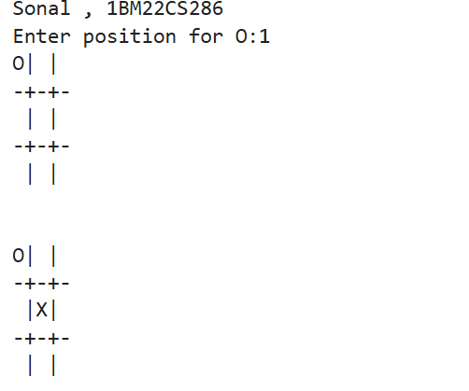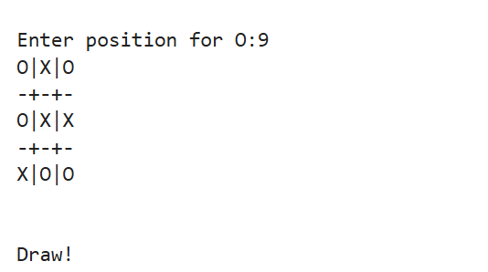

**Observation book screenshots:**

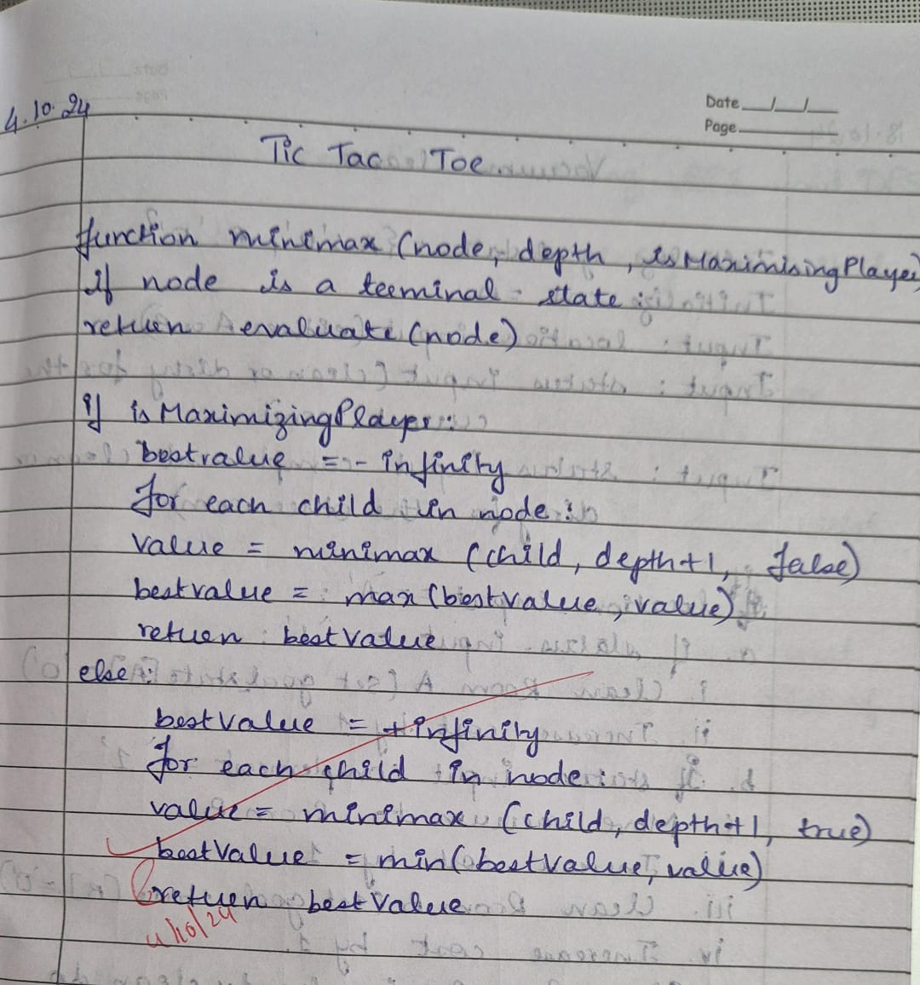

**2. Implement vacuum cleaner agent.**

**Code:**

**def vacuum_world():**

**# Initializing goal_state**

**# 0 indicates Clean and 1 indicates Dirty**

**goal_state = {'A': '0', 'B': '0'}**

**cost = 0**

**print("Sonal,1BM22CS286")**

**location_input = input("Enter Location of Vacuum (A or B): ").strip().upper() # User input of location**

**status_input = input(f"Enter status of {location_input} (0 for Clean, 1 for Dirty): ").strip()**

**status_input_complement = input("Enter status of other room (0 for Clean, 1 for Dirty): ").strip()**

**print("Initial Location Condition: " + str(goal_state))**

**if location_input == 'A':**

**print("Vacuum is placed in Location A")**

**if status_input == '1':**

**print("Location A is Dirty.")**

**goal_state['A'] = '0' # Clean A**

**cost += 1 # Cost for sucking**

**print("Cost for CLEANING A: " + str(cost))**

**print("Location A has been Cleaned.")**

**if status_input_complement == '1':**

**print("Location B is Dirty.")**

**print("Moving right to Location B.")**

**cost += 1 # Cost for moving right**

**print("Cost for moving RIGHT: " + str(cost))**

**goal_state['B'] = '0' # Clean B**

**cost += 1 # Cost for sucking**

**print("Cost for SUCK: " + str(cost))**

**print("Location B has been Cleaned.")**

**else:**

**print("Location B is already clean.")**

**else:**

**print("Location A is already clean.")**

**if status_input_complement == '1':**

**print("Location B is Dirty.")**

**print("Moving RIGHT to Location B.")**

**cost += 1 # Cost for moving right**

**print("Cost for moving RIGHT: " + str(cost))**

**goal_state['B'] = '0' # Clean B**

**cost += 1 # Cost for sucking**

**print("Cost for SUCK: " + str(cost))**

**print("Location B has been Cleaned.")**

**else:**

**print("Location B is already clean.")**

**elif location_input == 'B':**

**print("Vacuum is placed in Location B")**

**if status_input == '1':**

**print("Location B is Dirty.")**

**goal_state['B'] = '0' # Clean B**

**cost += 1 # Cost for sucking**

**print("Cost for CLEANING B: " + str(cost))**

**print("Location B has been Cleaned.")**

**if status_input_complement == '1':**

**print("Location A is Dirty.")**

**print("Moving LEFT to Location A.")**

**cost += 1 # Cost for moving left**

**print("Cost for moving LEFT: " + str(cost))**

**goal_state['A'] = '0' # Clean A**

**cost += 1 # Cost for sucking**

**print("Cost for SUCK: " + str(cost))**

**print("Location A has been Cleaned.")**

**else:**

**print("Location A is already clean.")**

**else:**

**print("Location B is already clean.")**

**if status_input_complement == '1':**

**print("Location A is Dirty.")**

**print("Moving LEFT to Location A.")**

**cost += 1 # Cost for moving left**

**print("Cost for moving LEFT: " + str(cost))**

**goal_state['A'] = '0' # Clean A**

**cost += 1 # Cost for sucking**

**print("Cost for SUCK: " + str(cost))**

**print("Location A has been Cleaned.")**

**else:**

**print("Location A is already clean.")**

**# Done cleaning**

**print("GOAL STATE: ")**

**print(goal_state)**

**print("Performance Measurement: " + str(cost))**

**# Output**

**vacuum_world()**

**Output:**

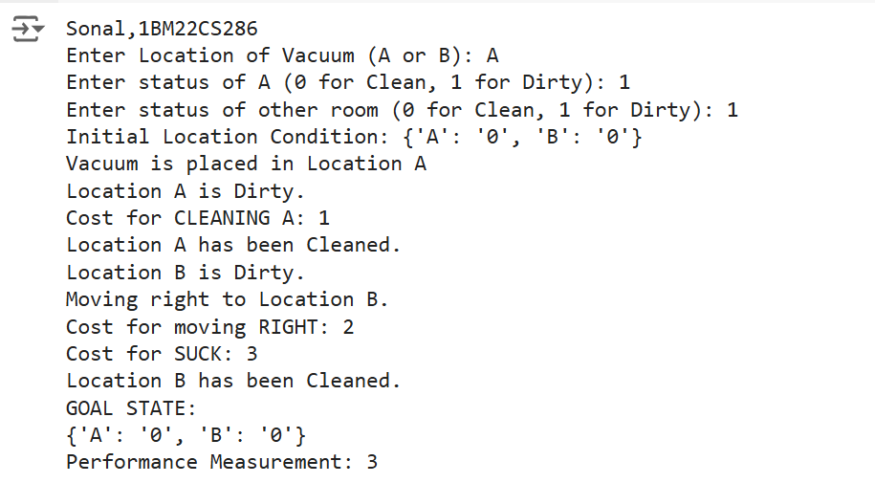

**Observation book screenshots:**

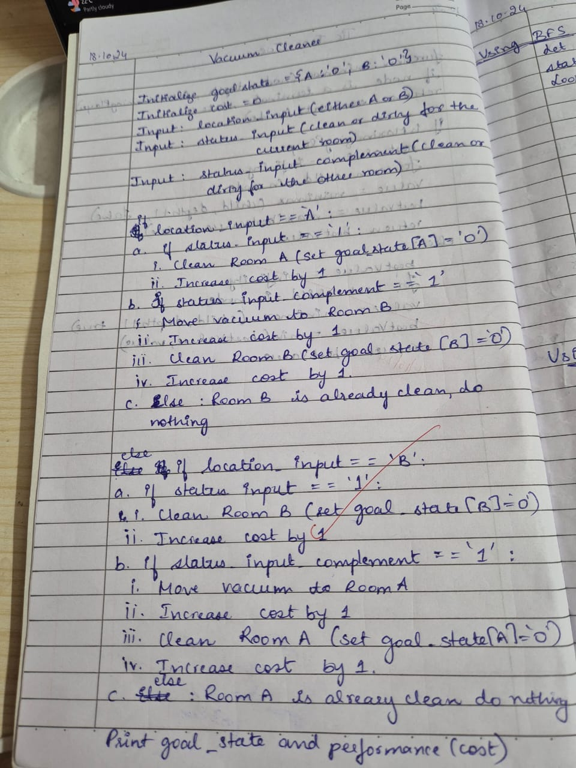

**3. Solve 8 puzzle problem using BFS and DFS.**

**USING BFS**

**Code:**

**from collections import deque**

**print("Sonal,1BM22CS286")**

**class PuzzleState:**

**def __init__(self, board, zero_position, path=[]):**

**self.board = board**

**self.zero_position = zero_position**

**self.path = path**

**def is_goal(self):**

**return self.board == [1, 2, 3, 4, 5, 6, 7, 8, 0]**

**def get_possible_moves(self):**

**moves = []**

**row, col = self.zero_position**

**directions = [(0, 1), (1, 0), (0, -1), (-1, 0)] # Right, Down, Left, Up**

**for dr, dc in directions:**

**new_row, new_col = row + dr, col + dc**

**if 0 <= new_row < 3 and 0 <= new_col < 3:**

**new_board = self.board[:]**

**# Swap zero with the adjacent tile**

**new_board[row * 3 + col], new_board[new_row * 3 + new_col] = new_board[new_row * 3 + new_col], new_board[row * 3 + col]**

**moves.append(PuzzleState(new_board, (new_row, new_col), self.path + [new_board]))**

**return moves**

**def bfs(initial_state):**

**queue = deque([initial_state])**

**visited = set()**

**while queue:**

**current_state = queue.popleft()**

**# Show the current board**

**print("Current Board State:")**

**print_board(current_state.board)**

**print()**

**if current_state.is_goal():**

**return current_state.path**

**visited.add(tuple(current_state.board))**

**for next_state in current_state.get_possible_moves():**

**if tuple(next_state.board) not in visited:**

**queue.append(next_state)**

**return None**

**def print_board(board):**

**for i in range(3):**

**print(board[i * 3:i * 3 + 3])**

**def main():**

**print("Enter the initial state of the 8-puzzle (use 0 for the blank tile, e.g., '1 2 3 4 5 6 7 8 0'): ")**

**user_input = input()**

**initial_board = list(map(int, user_input.split()))**

**if len(initial_board) != 9 or set(initial_board) != set(range(9)):**

**print("Invalid input! Please enter 9 numbers from 0 to 8.")**

**return**

**zero_position = initial_board.index(0)**

**initial_state = PuzzleState(initial_board, (zero_position // 3, zero_position % 3))**

**solution_path = bfs(initial_state)**

**if solution_path is None:**

**print("No solution found.")**

**else:**

**print("Solution found in", len(solution_path), "steps.")**

**for step in solution_path:**

**print_board(step)**

**print()**

**if __name__ == "__main__":**

**main()**

**Output :**

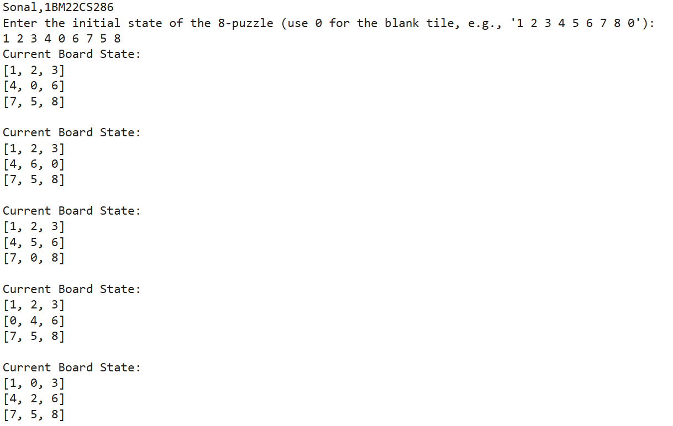

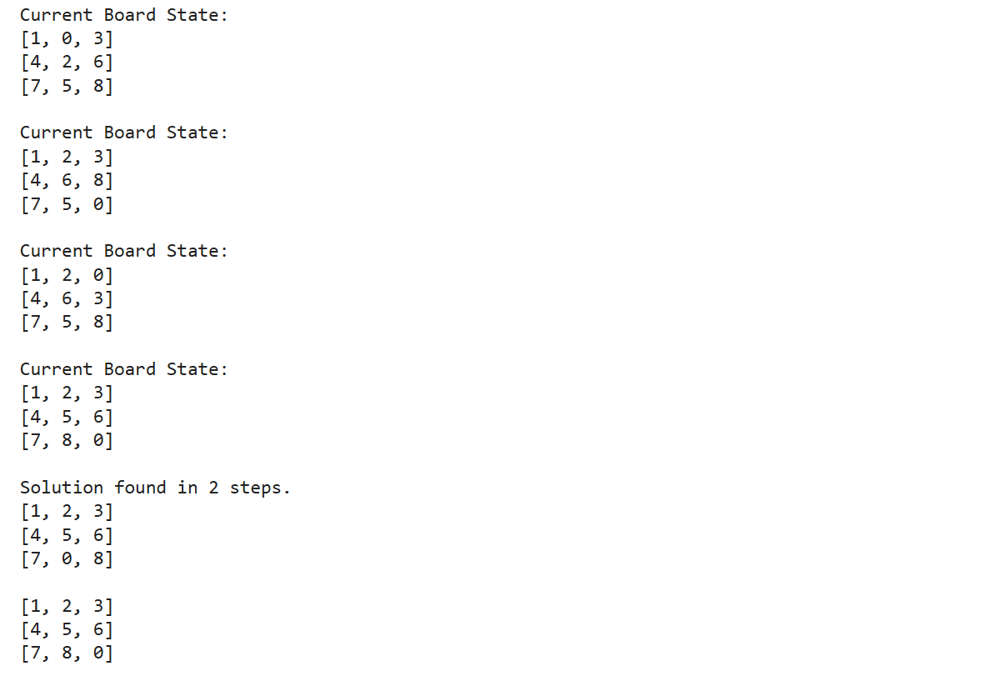

**Observation book screenshots:**

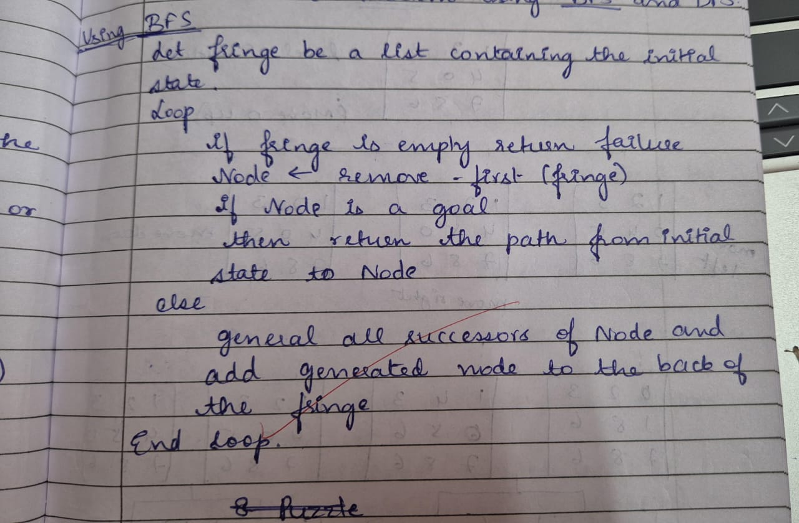

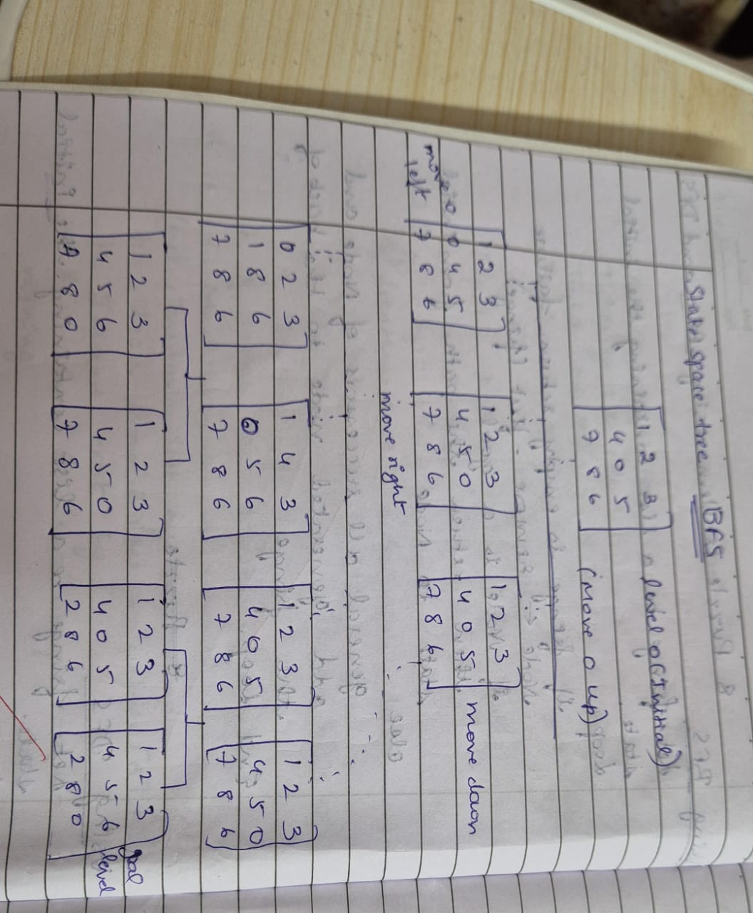

**USING DFS**

**Code :**

**from collections import deque**

**print("Sonal,1BM22CS286")**

**def get_user_input(prompt):**

**board = []**

**print(prompt)**

**for i in range(3):**

**row = list(map(int, input(f"Enter row {i+1} (space-separated numbers, use 0 for empty space): ").split()))**

**board.append(row)**

**return board**

**def is_solvable(board):**

**flattened_board = [tile for row in board for tile in row if tile != 0]**

**inversions = 0**

**for i in range(len(flattened_board)):**

**for j in range(i + 1, len(flattened_board)):**

**if flattened_board[i] > flattened_board[j]:**

**inversions += 1**

**return inversions % 2 == 0**

**class PuzzleState:**

**def __init__(self, board, moves=0, previous=None):**

**self.board = board**

**self.empty_tile = self.find_empty_tile()**

**self.moves = moves**

**self.previous = previous**

**def find_empty_tile(self):**

**for i in range(3):**

**for j in range(3):**

**if self.board[i][j] == 0:**

**return (i, j)**

**def is_goal(self, goal_state):**

**return self.board == goal_state**

**def get_possible_moves(self):**

**row, col = self.empty_tile**

**possible_moves = []**

**directions = [(1, 0), (-1, 0), (0, 1), (0, -1)] # down, up, right, left**

**for dr, dc in directions:**

**new_row, new_col = row + dr, col + dc**

**if 0 <= new_row < 3 and 0 <= new_col < 3:**

**# Make the move**

**new_board = [row[:] for row in self.board] # Deep copy**

**new_board[row][col], new_board[new_row][new_col] = new_board[new_row][new_col], new_board[row][col]**

**possible_moves.append(PuzzleState(new_board, self.moves + 1, self))**

**return possible_moves**

**def dfs(initial_state, goal_state):**

**stack = [initial_state]**

**visited = set()**

**while stack:**

**current_state = stack.pop()**

**if current_state.is_goal(goal_state):**

**return current_state**

**# Convert board to a tuple for the visited set**

**state_tuple = tuple(tuple(row) for row in current_state.board)**

**if state_tuple not in visited:**

**visited.add(state_tuple)**

**for next_state in current_state.get_possible_moves():**

**stack.append(next_state)**

**return None # No solution found**

**def print_solution(solution):**

**path = []**

**while solution:**

**path.append(solution.board)**

**solution = solution.previous**

**for state in reversed(path):**

**for row in state:**

**print(row)**

**print()**

**if __name__ == "__main__":**

**# Get user input for initial and goal states**

**initial_board = get_user_input("Enter the initial state of the puzzle:")**

**goal_board = get_user_input("Enter the goal state of the puzzle:")**

**if is_solvable(initial_board):**

**initial_state = PuzzleState(initial_board)**

**solution = dfs(initial_state, goal_board)**

**if solution:**

**print("Solution found in", solution.moves, "moves:")**

**print_solution(solution)**

**else:**

**print("No solution found.")**

**else:**

**print("This puzzle is unsolvable.")**

**Output:**

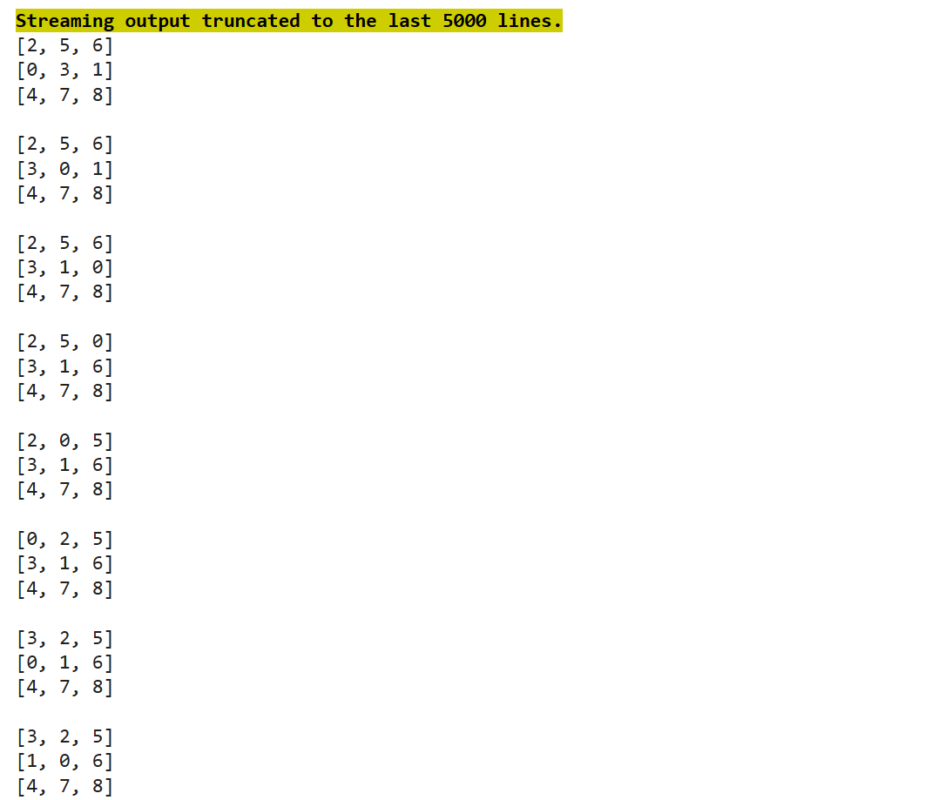

**Observation book screenshots:**

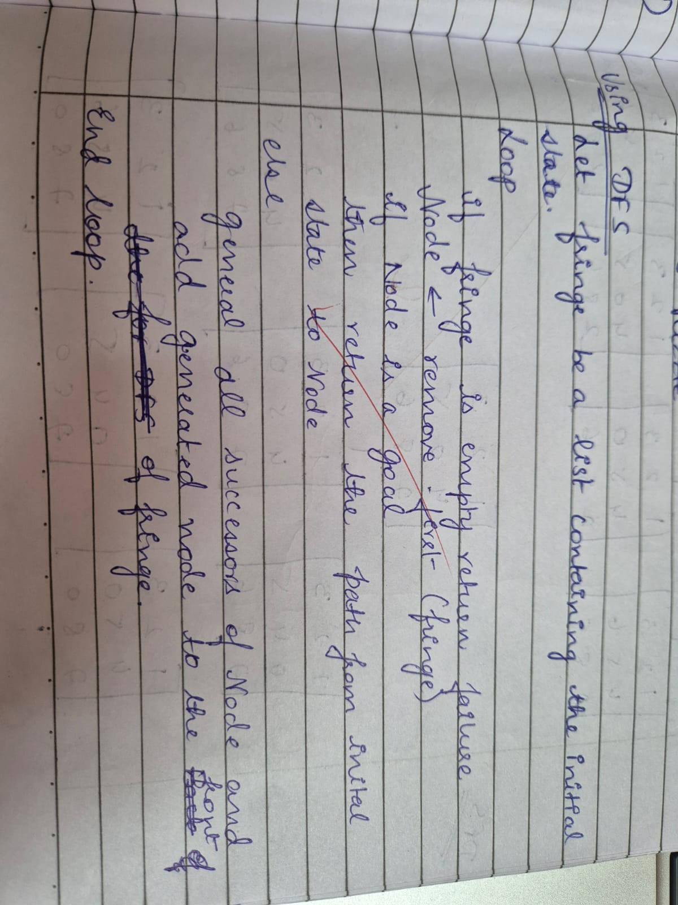

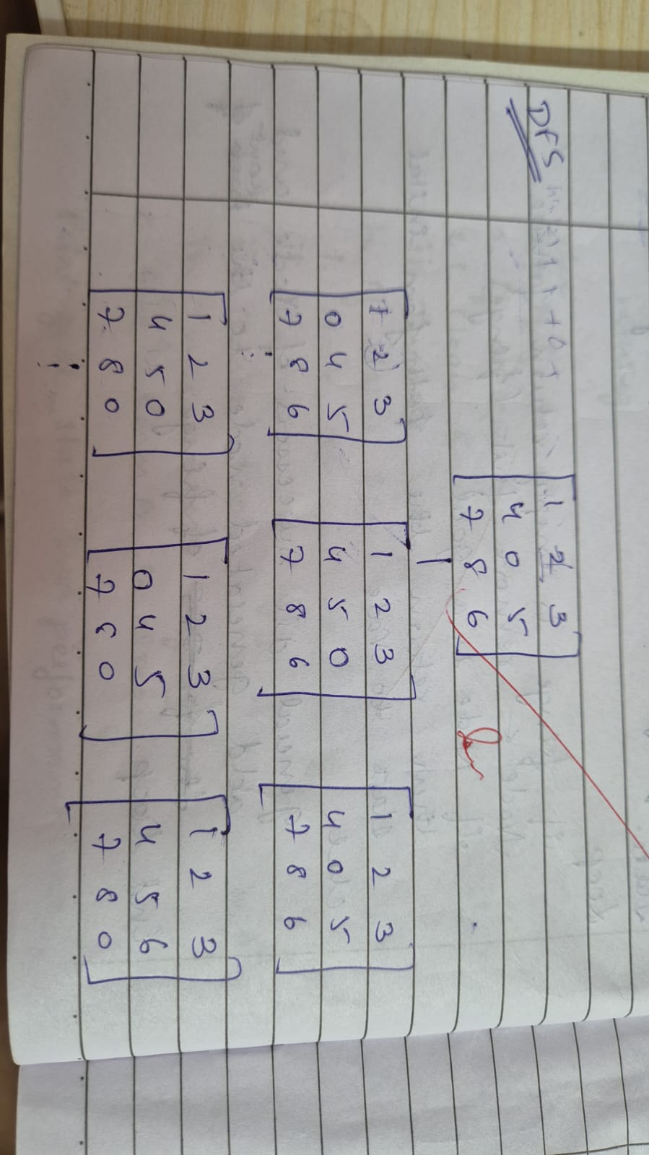

**4. Solve 8 puzzle problem using A* algorithm**

**Using misplaced tiles**

**Code:**

**import heapq**

**print("Sonal,1BM22CS286")**

**# Define the goal state for the 8-puzzle**

**GOAL_STATE = [**

**[2, 8, 1],**

**[0, 4, 3],**

**[7, 6, 5]**

**]**

**# Define the position moves (up, down, left, right)**

**MOVES = [**

**(-1, 0), # Up**

**(1, 0), # Down**

**(0, -1), # Left**

**(0, 1) # Right**

**]**

**class PuzzleNode:**

**def __init__(self, state, parent=None, g=0, h=0):**

**self.state = state**

**self.parent = parent**

**self.g = g # Cost from start to current node**

**self.h = h # Heuristic cost to goal**

**self.f = g + h # Total cost**

**def __lt__(self, other):**

**return self.f < other.f**

**def misplaced_tiles(state):**

**"""Heuristic function that counts the number of misplaced tiles."""**

**misplaced = 0**

**for i in range(3):**

**for j in range(3):**

**if state[i][j] != 0 and state[i][j] != GOAL_STATE[i][j]:**

**misplaced += 1**

**return misplaced**

**def get_zero_position(state):**

**"""Find the position of the zero (empty tile) in the puzzle."""**

**for i in range(3):**

**for j in range(3):**

**if state[i][j] == 0:**

**return i, j**

**return None**

**def generate_successors(node):**

**"""Generate successors by moving the empty tile in all possible directions."""**

**successors = []**

**zero_x, zero_y = get_zero_position(node.state)**

**for move_x, move_y in MOVES:**

**new_x, new_y = zero_x + move_x, zero_y + move_y**

**if 0 <= new_x < 3 and 0 <= new_y < 3:**

**new_state = [row[:] for row in node.state]**

**new_state[zero_x][zero_y], new_state[new_x][new_y] = new_state[new_x][new_y], new_state[zero_x][zero_y]**

**h = misplaced_tiles(new_state)**

**successors.append(PuzzleNode(new_state, parent=node, g=node.g + 1, h=h))**

**return successors**

**def is_goal(state):**

**"""Check if the current state is the goal state."""**

**return state == GOAL_STATE**

**def reconstruct_path(node):**

**"""Reconstruct the path from the start state to the goal state."""**

**path = []**

**while node:**

**path.append(node.state)**

**node = node.parent**

**return path[::-1]**

**def a_star(start_state):**

**"""A* algorithm to solve the 8-puzzle problem."""**

**start_node = PuzzleNode(start_state, g=0, h=misplaced_tiles(start_state))**

**open_list = []**

**closed_set = set()**

**heapq.heappush(open_list, start_node)**

**while open_list:**

**current_node = heapq.heappop(open_list)**

**if is_goal(current_node.state):**

**return reconstruct_path(current_node)**

**closed_set.add(tuple(map(tuple, current_node.state)))**

**for successor in generate_successors(current_node):**

**if tuple(map(tuple, successor.state)) in closed_set:**

**continue**

**heapq.heappush(open_list, successor)**

**return None**

**def get_user_input():**

**"""Get a valid 8-puzzle input state from the user."""**

**print("Enter your 8-puzzle configuration (0 represents the empty tile):")**

**state = []**

**values = set()**

**for i in range(3):**

**row = input(f"Enter row {i+1} (space-separated numbers between 0 and 8): ").split()**

**if len(row) != 3:**

**print("Each row must have exactly 3 numbers. Please try again.")**

**return None**

**row = [int(x) for x in row]**

**if not all(0 <= x <= 8 for x in row):**

**print("Values must be between 0 and 8. Please try again.")**

**return None**

**state.append(row)**

**values.update(row)**

**if values != set(range(9)):**

**print("All numbers from 0 to 8 must be present exactly once. Please try again.")**

**return None**

**return state**

**# Main function**

**def main():**

**start_state = None**

**while start_state is None:**

**start_state = get_user_input()**

**solution = a_star(start_state)**

**# Print the solution steps**

**if solution:**

**print("Solution found in", len(solution) - 1, "moves:")**

**for step in solution:**

**for row in step:**

**print(row)**

**print()**

**else:**

**print("No solution found.")**

**if __name__ == "__main__":**

**main()**

**Output:**

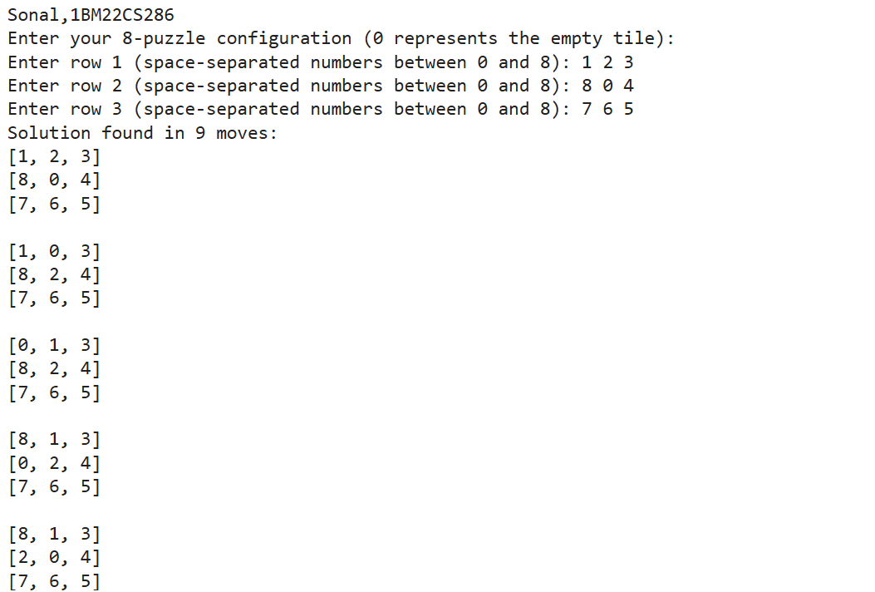

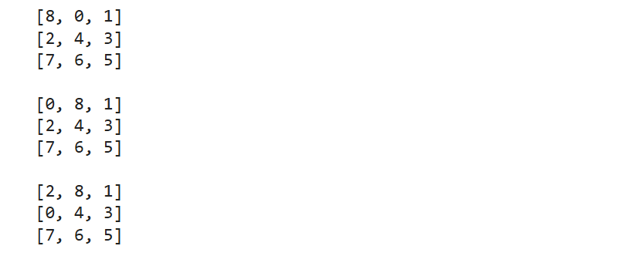

**Observation book screenshots:**

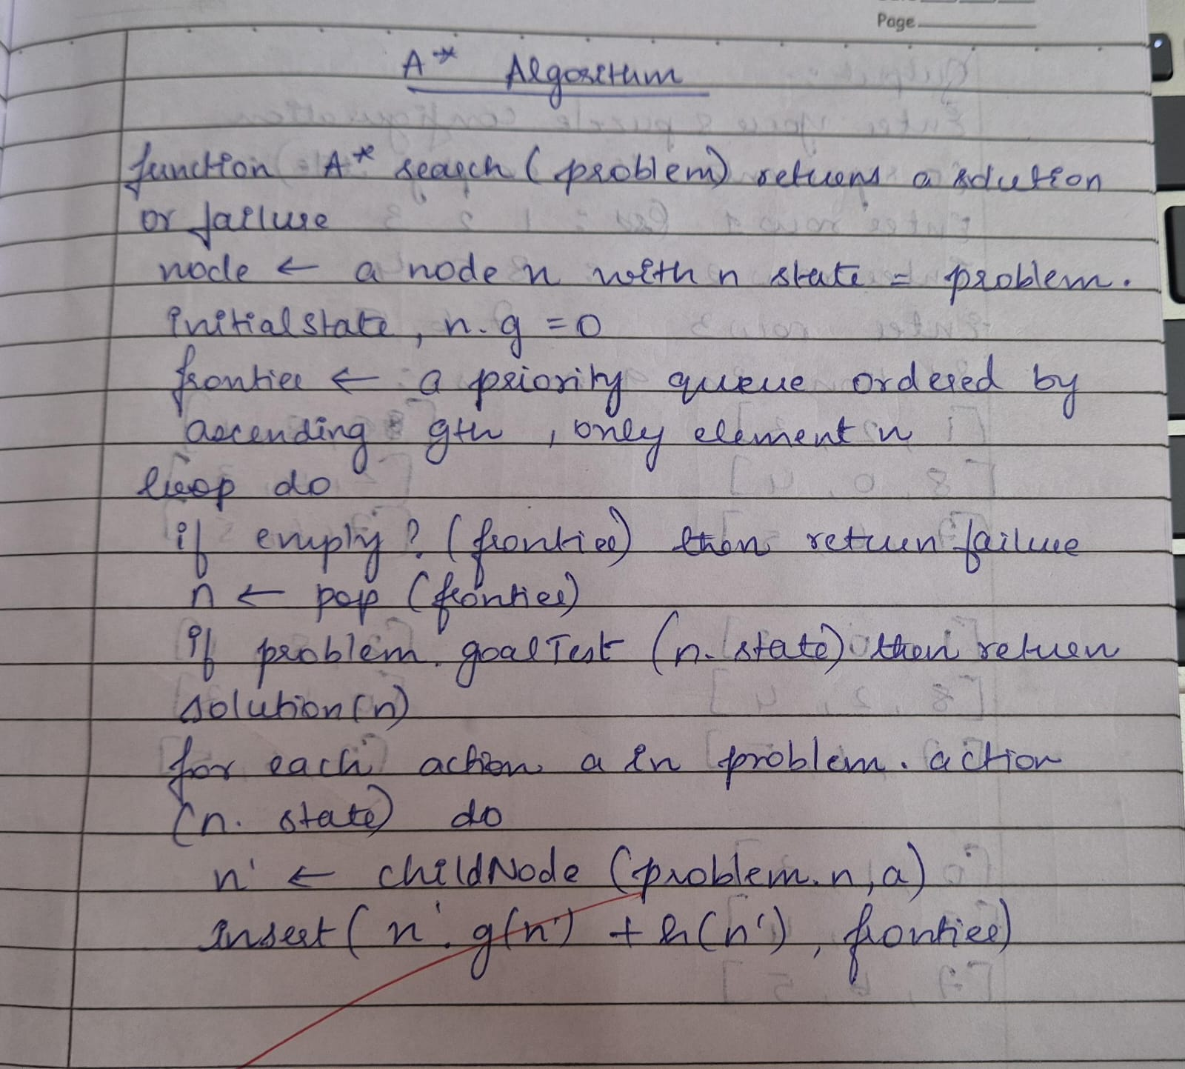

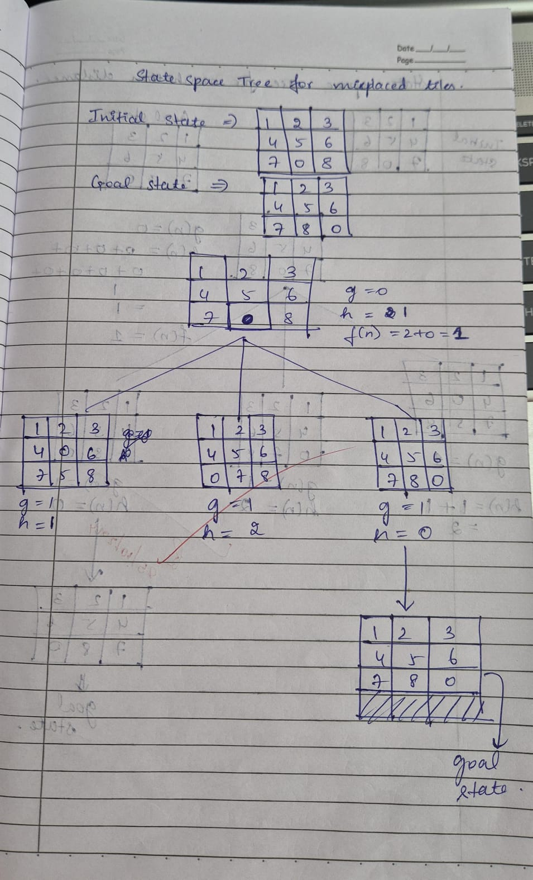

**Using Manhattan distance:**

**Code:**

**# manhattan distance**

**import heapq**

**print("Sonal,1BM22CS286")**

**# Define the goal state for the 8-puzzle**

**GOAL_STATE = [**

**[2, 8, 1],**

**[0, 4, 3],**

**[7, 6, 5]**

**]**

**# Define the position moves (up, down, left, right)**

**MOVES = [**

**(-1, 0), # Up**

**(1, 0), # Down**

**(0, -1), # Left**

**(0, 1) # Right**

**]**

**class PuzzleNode:**

**def __init__(self, state, parent=None, g=0, h=0):**

**self.state = state**

**self.parent = parent**

**self.g = g # Cost from start to current node**

**self.h = h # Heuristic cost to goal (Manhattan distance)**

**self.f = g + h # Total cost**

**def __lt__(self, other):**

**return self.f < other.f**

**def manhattan_distance(state):**

**"""Heuristic function that calculates the Manhattan distance for each tile."""**

**distance = 0**

**for i in range(3):**

**for j in range(3):**

**value = state[i][j]**

**if value != 0: # Skip the empty tile**

**# Calculate goal position for this value**

**goal_x, goal_y = (value - 1) // 3, (value - 1) % 3**

**# Add the Manhattan distance for this tile**

**distance += abs(i - goal_x) + abs(j - goal_y)**

**return distance**

**def get_zero_position(state):**

**"""Find the position of the zero (empty tile) in the puzzle."""**

**for i in range(3):**

**for j in range(3):**

**if state[i][j] == 0:**

**return i, j**

**return None**

**def generate_successors(node):**

**"""Generate successors by moving the empty tile in all possible directions."""**

**successors = []**

**zero_x, zero_y = get_zero_position(node.state)**

**for move_x, move_y in MOVES:**

**new_x, new_y = zero_x + move_x, zero_y + move_y**

**if 0 <= new_x < 3 and 0 <= new_y < 3:**

**new_state = [row[:] for row in node.state]**

**new_state[zero_x][zero_y], new_state[new_x][new_y] = new_state[new_x][new_y], new_state[zero_x][zero_y]**

**h = manhattan_distance(new_state)**

**successors.append(PuzzleNode(new_state, parent=node, g=node.g + 1, h=h))**

**return successors**

**def is_goal(state):**

**"""Check if the current state is the goal state."""**

**return state == GOAL_STATE**

**def reconstruct_path(node):**

**"""Reconstruct the path from the start state to the goal state."""**

**path = []**

**while node:**

**path.append(node.state)**

**node = node.parent**

**return path[::-1]**

**def a_star(start_state):**

**"""A* algorithm to solve the 8-puzzle problem."""**

**start_node = PuzzleNode(start_state, g=0, h=manhattan_distance(start_state))**

**open_list = []**

**closed_set = set()**

**heapq.heappush(open_list, start_node)**

**while open_list:**

**current_node = heapq.heappop(open_list)**

**if is_goal(current_node.state):**

**return reconstruct_path(current_node)**

**closed_set.add(tuple(map(tuple, current_node.state)))**

**for successor in generate_successors(current_node):**

**if tuple(map(tuple, successor.state)) in closed_set:**

**continue**

**heapq.heappush(open_list, successor)**

**return None**

**def get_user_input():**

**"""Get a valid 8-puzzle input state from the user."""**

**print("Enter your 8-puzzle configuration (0 represents the empty tile):")**

**state = []**

**values = set()**

**for i in range(3):**

**row = input(f"Enter row {i+1} (space-separated numbers between 0 and 8): ").split()**

**if len(row) != 3:**

**print("Each row must have exactly 3 numbers. Please try again.")**

**return None**

**row = [int(x) for x in row]**

**if not all(0 <= x <= 8 for x in row):**

**print("Values must be between 0 and 8. Please try again.")**

**return None**

**state.append(row)**

**values.update(row)**

**if values != set(range(9)):**

**print("All numbers from 0 to 8 must be present exactly once. Please try again.")**

**return None**

**return state**

**# Main function**

**def main():**

**start_state = None**

**while start_state is None:**

**start_state = get_user_input()**

**solution = a_star(start_state)**

**# Print the solution steps**

**if solution:**

**print("Solution found in", len(solution) - 1, "moves:")**

**for step in solution:**

**for row in step:**

**print(row)**

**print()**

**else:**

**print("No solution found.")**

**if __name__ == "__main__":**

**main()**

**Output:**

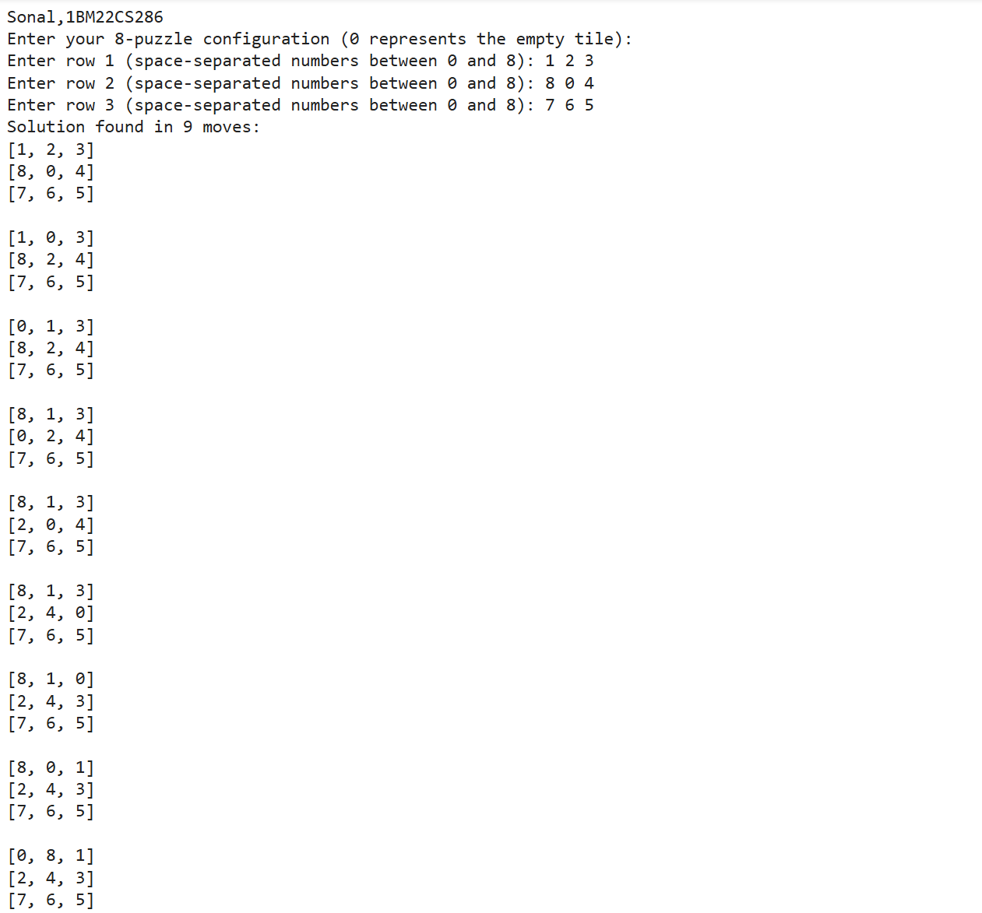

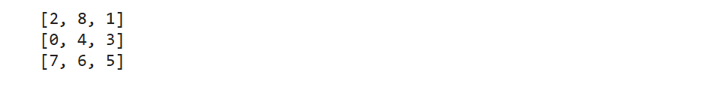

**Observation book screenshots:**

